Caroline Cutter

NSCI 1230

January 21, 2022

**Homework 5: Incorporating a Stimulus**

**PART 1:** Use R to make one of the figures you sketched.

**Raster Plots:**

I created two raster plots with the 10 neurons/trials across time. They are both the exact same but the plot on the top has been color coded according to cell/trial. I do feel that color coding is more effective for less neurons/trials, but in this case, I think the black and white works best. I felt that the black and white image on the left was more effective in comparing spike times because it is easier to show comparisons across time when they are all the same color.

**PART 2:** Compute measures for times when the stimulus is on or off.

1. **Firing Rate / Fano Factor:**

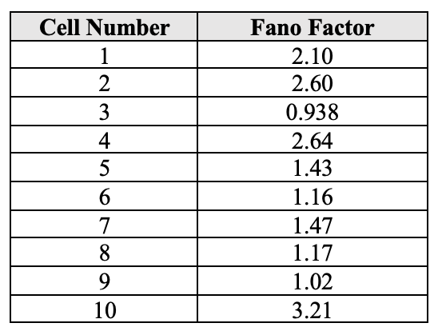

1. **Synchrony**

1. **ISI Graphs & CV**

1. **What do your visualizations tell you about these recordings in the Monkey motor cortex and how they may or may not change characteristics with the stimulus?**

**Firing Rate / Fano Factor:**

From both firing rate graphs above, we can see that the neuron(s) seem to have a higher average firing rate after the stimulus occurs. In both sized bins, the highest average firing rate happens in the second half of the recorded stimulus. I calculated the Fano Factors in two different ways – one was for each cell/trial across bins of size .5 seconds and then one by splitting the trials into “before, during, after” stimulus labels over a .25 second bin. More of the Fano factors were above 1, which means they are less regular than a Poisson and means they have variable firing rates through the times of the trials. The Fano Factor during the stimulus was below 1 which means it is more regular than a Poisson distribution which makes sense because they would be expected to have a similar firing rate during the stimulus.

**Synchrony:**

Originally to measure synchrony we split the bins up so there could only be 1 spike per neuron, in this case that bin size would have to be .002 seconds. This bin size was too small so instead I increased the bin size to .05 and measured synchrony using a firing rate distribution. We can see that this neuron or network of neurons is quite synchronous because the firing rates alter up and down together. Also, there was a higher firing rate during the stimulus which shows that this neuron/network fired in response to that stimulus together.

**ISI & CV:**

The ISI graphs were divided into before, during and after stimulus intervals. There were more spikes in the before and after than the during stimulus, which accounts for the different scales on the Y-axis. All three of the graphs have peaks at distinct intervals, which shows that they are fairly regular in their Interspike intervals. I wouldn’t say that the during stimulus has a drastically more distinct interval, so there is not much to conclude from the graphs themselves. However, the CV for the during stimulus is the only one less than one, which means it is more regular than Poisson and has more regular inter spike intervals than the before and after stimulus. This is to be expected because if a neuron/network is responding to a stimulus, you would expect it to have a more regular firing pattern than randomly firing neurons.

**PART 3:** Tell a story about the data. Explain to someone with little neuroscience background what you think is happening with the stimulus. How may this interpretation differ if these recordings came from 10 different neurons or the same neuron across 10 different trials.

I believe that this neuron/network is responding to the stimulus because as we saw in the explanations above, it has a higher firing rate after the stimulus starts, has more regular Interspike intervals (CV), and has a more regular number of spike counts (Fano factor). I believe that when the monkey reaches for the hand control, this stimulates this neuron/network of neurons in the motor cortex, which then leads to the neurons firing more regularly and at a higher firing rate.

If this was just a single neuron, I believe that my interpretation of the synchrony section would change because instead of measuring synchrony of a network and neurons firing together, it is more a measure of variability in the neurons firing in response to the same stimulus.